Test Closure Report for
<PROJECT NAME>

General information
Customer | <Project name>
Created by (Author)
Preparation date
Version
Status

Revision History
Version | Description | Author | Date | Approved by
 |  |  |  | Author | Date

Summary
Table of Contents
Introduction 4
Purpose 4
Application Overview 4
Release Recommendation Summary 4
Testing Scope 5
In Scope 5
Out of Scope 5
Items Not Tested 5
RAG Status Dashboard 5
Test Execution Summary 6
Defect Analysis 6
Metrics & KPIs 6
Test Dashboard & Visual Metrics 7
Types of Testing Performed 9
Risks & Mitigation 9
Risks 9
Mitigation 10
Lessons Learned 10
What Went Well 10
Opportunities for Improvement 10
Recommendations for Future Releases 11
Process Improvements Identified 11
Exit Criteria Validation 11
Approvals 11
Open Defects Accepted for Release 12
Final Recommendation 12

Introduction

Purpose
The purpose of this Test Closure Report is to summarize the testing activities completed for the release and provide a final view of quality, execution status, defects, risks, metrics, and release readiness.
This report provides stakeholders with a consolidated summary of testing coverage, defect analysis, open risks, lessons learned, stakeholder approvals, and the final Go / No-Go recommendation.

Application Overview
This report applies to an enterprise application supporting key business functions across multiple business units and user groups.
The release includes a combination of enhancements, defect fixes, integration updates, process improvements, and system stabilization activities.
Key impacted areas may include:
• Customer and user management
• Reporting and dashboard functionality
• Workflow and approval processes
• System integrations and interfaces
• Data processing and validation
• Notifications and communication flows
• Security roles and access controls
Major integrations may include third-party systems, APIs, external platforms, reporting tools, data interfaces, and downstream applications.
The release impacts multiple stakeholder groups including business users, QA teams, development teams, support teams, operations teams, project managers, and business leadership.

Release Recommendation Summary
• Overall release quality is considered stable and ready for deployment
• All critical business scenarios were validated successfully
• No Critical or High severity defects remain open
• Remaining open defects are Medium or Low severity with approved workarounds
• UAT sign-off completed
• Recommendation: GO for Production Deployment

Testing Scope

In Scope

• Functional testing
• System and integration testing
• API / Interface testing
• Regression testing
• Smoke testing
• Cross-browser and device testing
• UAT support
• Automation testing
• Data validation testing

Out of Scope

• Features not included in the release scope
• Performance testing beyond agreed limits
• Security or penetration testing by external teams
• Third-party systems unavailable in lower environments
• Legacy browser or unsupported device testing

RAG Status Dashboard
Area | Status | Notes
Scope Coverage | Green | Planned scope completed
Defects | Amber | Few Medium/Low defects open
UAT Completion | Green | UAT completed successfully
Risks | Amber | Minor environment and dependency risks remain
Deployment Readiness | Green | Rollback and smoke plan prepared

Test Execution Summary
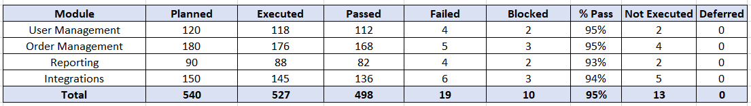
Overall test execution reached 98% completion with a 95% pass rate. Failed scenarios were primarily linked to integration and environment issues and were addressed through retesting and defect resolution.

Defect Analysis

Defect ID | Severity | Priority | Module | Status | Resolution
DEF-101 | Critical | High | Login | Closed | Fixed and retested
DEF-118 | High | High | Payments | Closed | Fixed and retested
DEF-142 | Medium | Medium | Reporting | Open | Accepted for future release
DEF-156 | Low | Low | Notifications | Open | Workaround available

A total of 60 defects were identified during testing. All Critical and High severity defects were resolved prior to closure. Remaining open defects are Medium and Low severity with agreed workarounds and planned future fixes.

Metrics & KPIs

Metric / KPI | Value
Test Execution Progress | 98%
Pass Rate | 95%
Fail Rate | 3%
Blocked Test Cases | 2%
Test Coverage | 96%
Requirement Coverage | 97%
Open Defects | 8
Closed Defects | 52
Defect Trend by Severity | 4 Critical, 12 High, 26 Medium, 18 Low defects identified during testing
Defect Leakage Rate | 3%
Defect Removal Efficiency | 91%
Reopen Percentage | 4%
Defect Rejection Rate | 6%
Test Case Effectiveness | 89%
Automation Coverage | 62%
Automation Execution Time Saved | Approximately 120 hours across regression cycles
Mean Time to Detect (MTTD) | 1.5 days
Mean Time to Resolve (MTTR) | 2.8 days
Defect Density | 0.8 defects per requirement
Test Case Productivity | Average of 18 test cases designed and executed per tester per day

Test Dashboard & Visual Metrics

The following charts provide a visual representation of test execution progress, defect trends, and overall release quality.
• Test Execution Trend – Planned vs Executed vs Passed across test cycles or weeks
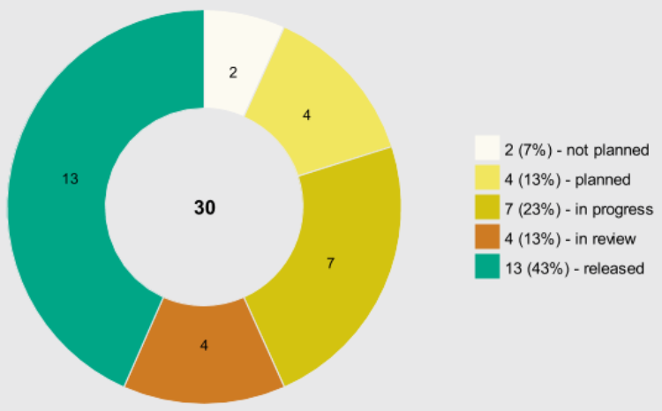

• Defect Severity Distribution – Critical, High, Medium, Low defects identified during testing
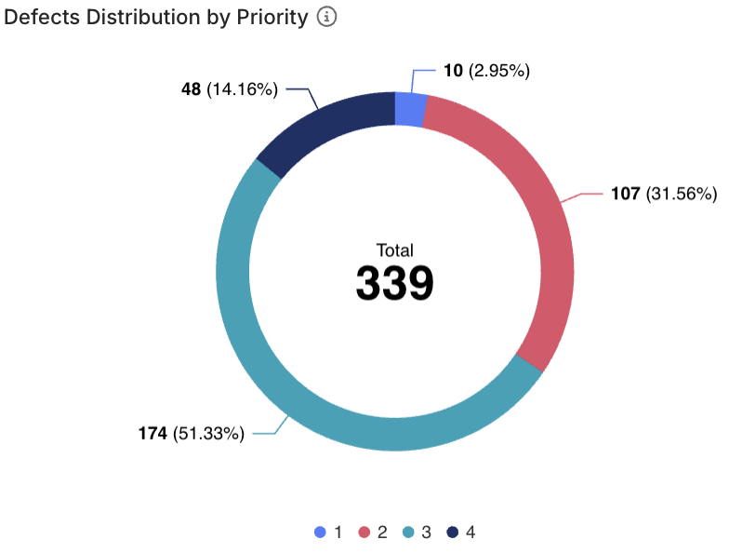
• Open vs Closed Defects Trend – Status of defects across test cycles
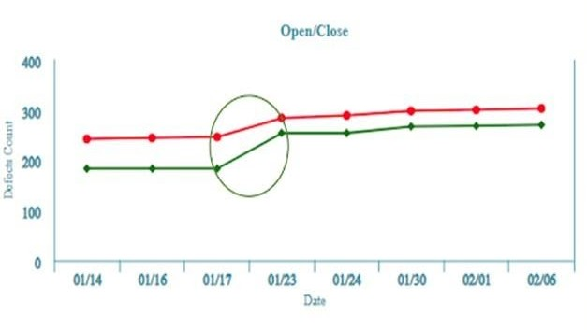

• Pass vs Fail Pie Chart – Distribution of passed, failed, and blocked test cases
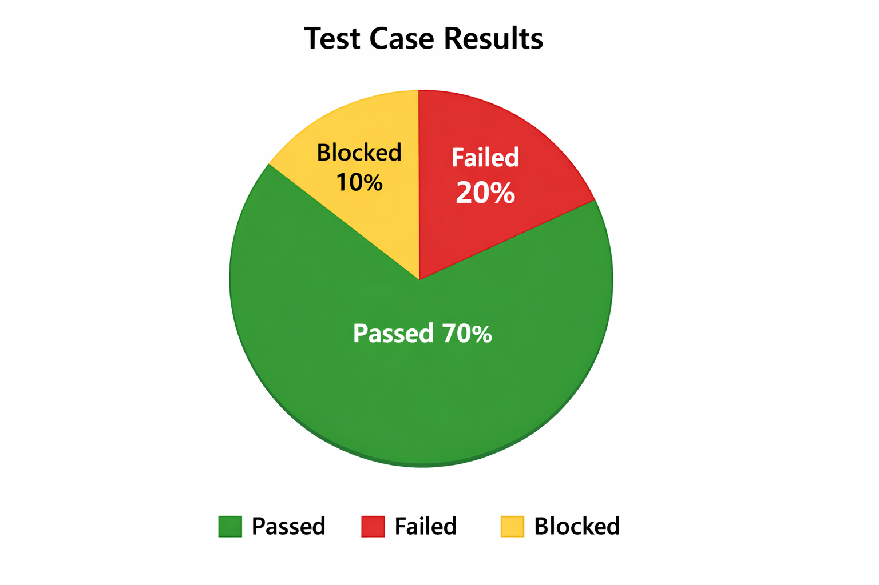

Types of Testing Performed

• Smoke Testing
• Functional Testing
• System Testing
• Integration Testing
• API / Interface Testing
• Regression Testing
• End-to-End Testing
• Data Validation Testing
• Automation Regression Testing
• UAT Support Testing

Risks & Mitigation

This section should document the major risks identified during testing and the actions taken to reduce their impact.

Risks
• Delayed environment availability impacting execution timelines
• Third-party integrations being unstable during testing
• Limited or incomplete test data causing execution delays
• High defect volume impacting regression timelines
• Frequent requirement changes affecting testing scope
• Delays in defect resolution or retesting
• Limited availability of business users or stakeholders

Mitigation
• Daily defect triage meetings conducted
• Additional environment refreshes completed
• Business and development teams supporting test data preparation
• Regression scope prioritized for critical business modules
• Additional test cycles planned for high-risk areas
• Early stakeholder communication and planning sessions
• Backup resources or contingency plans prepared for critical activities

Lessons Learned

What Went Well
• Early involvement of QA improved requirement clarity and reduced rework during execution
• Regular defect triage meetings improved turnaround time and defect resolution efficiency
• Automation significantly reduced regression effort and increased repeatability across releases
• Strong collaboration between QA, business, development, and support teams improved delivery timelines
• Daily status reporting and stakeholder communication helped identify risks early
• Business-critical workflows were validated successfully with minimal rework required
• Reusable test assets and regression suites improved execution efficiency across cycles

Opportunities for Improvement
• Environment readiness should be completed earlier to avoid delays in execution
• Test data preparation should begin sooner for complex business scenarios
• Requirement gaps and ambiguous acceptance criteria should be clarified before testing begins
• Additional integration, negative, and edge-case testing should be included
• More automation coverage can be added for repetitive and high-volume scenarios
• Defect retesting timelines can be improved through better coordination with development teams
• UAT planning and stakeholder availability should be confirmed earlier in the cycle

Recommendations for Future Releases
• Involve QA earlier during requirement, design, and estimation discussions
• Improve test data preparation and environment readiness timelines
• Increase automation coverage for repetitive, high-risk, and regression-heavy areas
• Strengthen integration testing across dependent systems and third-party interfaces
• Conduct more frequent risk reviews and stakeholder checkpoints throughout the project lifecycle
• Improve traceability between requirements, test cases, defects, and business sign-offs
• Introduce earlier performance and security validation for high-impact releases

Process Improvements Identified
• Improve defect triage, prioritization, and escalation processes
• Enhance communication between QA, development, business, and support teams
• Standardize reporting templates, dashboards, and release metrics across projects
• Introduce earlier review cycles for requirements, test cases, and defect prevention activities
• Improve reuse of automation scripts, regression suites, and test data assets
• Establish better entry and exit criteria for each testing phase
• Strengthen governance around defect acceptance and release readiness reviews

Exit Criteria Validation
The following conditions should be met before testing is considered complete:
• All planned test cases are executed
• All Critical and High severity defects are closed
• Business-critical workflows are validated successfully
• No blocker defects remain open
• Test summary and closure reports are completed
• Stakeholder sign-off is received
• Remaining open defects are reviewed, documented, and accepted
• Deployment readiness activities, rollback planning, and smoke test preparation are completed

Approvals

The following stakeholders reviewed the testing results, defect status, risks, and release readiness details prior to final sign-off.
Role | Name | Approval Status | Date
QA Lead
Project Manager
Development Manager
Business Analyst
Business Owner / Stakeholder

Open Defects Accepted for Release

The following open defects were reviewed with stakeholders and accepted for deployment due to low business impact and available workarounds.
Defect ID | Description | Severity | Reason for Acceptance | Workaround Available | Planned Fix Release
DEF-142 | Export report formatting issue | Medium | Low business impact | Yes | Next release
DEF-156 | Notification delay for some users | Low | Does not block business flow | Yes | Next release

Final Recommendation
Based on completed testing activities, defect closure status, UAT validation, and deployment readiness assessment, the release is recommended for production deployment.
All Critical and High severity defects have been resolved. Remaining open defects are Medium or Low severity with documented workarounds and stakeholder approval.
Residual risk is considered acceptable and manageable based on current defect status, mitigation plans, and stakeholder approval.
Overall application quality is considered stable with manageable residual risk.

